Rural Visibility Project Toolkit
Project Information and Participation Guide

Thank you for joining the Rural Visibility Project. This guide tells you exactly how to join in, what to post, when to share, and how to stay connected to the movement.

What is the Rural Visibility Project?
A yearlong campaign designed to center rural priorities through community-driven dialogue between local, state, and regional entities. This organizing strategy, powered by rural people and structured around monthly topics, shifts public attention to the realities, concerns, and possibilities that matter in the places we call home.

Each month follows a four-week schedule covering:
1) Rural Realities
2) Rural Ideals
3) Methods and Models
4) Key Players and Stakeholders

A virtual conversation will occur between the 3rd and 4th week of each month to reflect on what we learned and next steps toward success in the topic area for rural communities.

Ways to Get Involved

Issue Leads: Rural Leaders who work and serve rural on one of the monthly topics. They can:
- Suggest topic focuses and guiding questions
- Gather key data, stories, and examples on issue topic
- Share information on topic through your organization’s communication channels. Use hashtags provided by RDI
- Help local storytellers, leaders, and policy makers join the conversation
- Participate in design meetings for virtual conversation
- Attend virtual conversations and provide insight into the topic issue
- Support and convene rural leaders who are interested in taking action on the issue topic

Rural Champions: anyone who lives, serves, or supports rural areas and have interest in learning more about specific monthly topics and want to help spread information throughout their networks. They can:
- Repost stories around monthly topic from rural communities across the state. Use hashtags provided by RDI
- Bring in emerging leaders, youth, and neighbors to join conversations and efforts
- Engage in online and offline conversations and events related to monthly topics
- Work with community leaders, elected officials and associations to strengthen local and statewide efforts
- Explore what is happening in your community around the issues you care about and share lessons with RVP network

Legislators / Funders / Policy Makers: key players in state government who create state policy; statewide and local entities whose missions align with – and funds go toward – rural community interests and priorities. They can:
- Engage with RVP by listening, learning, and connecting with rural constituents and grantees; deepen their understanding of rural communities
- Incorporate rural voices in legislative platforms and policies
- Participate in conversations to better understand local challenges and opportunities
- Contribute expertise, resources, and networks to strengthen funding and capacity
- Share information and encourage peer learning across funding communities

We invite you to amplify rural voices during each month, focusing on the topics that resonate with you the most. An interest form is available to all who would like to engage on our website (ruralvisibilityproject.org) to inform the RDI team about the months that interest you. Reminder emails for info sessions, community conversations, and the start of each monthly topic will go out to those who fill out the interest form.

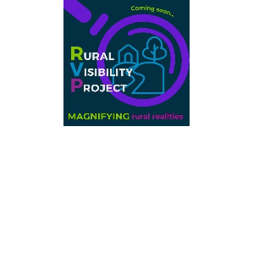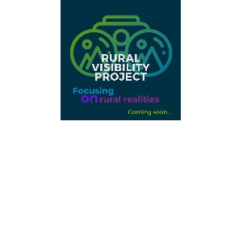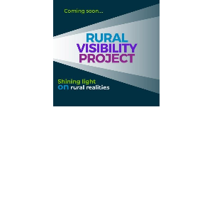

Information Sharing Guide

As a participant in this movement, you can help amplify rural stories by:
- Sharing 1–2 posts per week that match the weekly theme and align with the monthly issue topic
- Using our shared hashtags and tagging RDI so we can repost
- Lifting up stories, wins, and community voices from your own region.
- Reposting content from monthly Issue Leaders to build momentum

You do not need brand new content - feel free to re-share posts you have already created or repost issue specific content you have seen from others in your network.

Rural Visibility Project – General Promotion
- Use any of the visuals above
Optional Captions – feel free to write your own and run it by me for review.
- Rural people deserve to be heard—loud and clear.
Through monthly themes and shared storytelling, the Rural Visibility Project lifts up rural realities and builds momentum for change. Join us in this movement with our soft launch in September 2025. For more information, contact kschaffer@rdiinc.org. #RuralVisibilityProject
- Something’s coming…
In September, RDI is soft-launching the Rural Visibility Project—a community-powered campaign to center rural voices and priorities in public conversations across the Pacific Northwest. Be ready to share stories and engage in discussion around rural topics with community leaders, state agencies, and decision and policy makers. #RuralVoices #RuralVisibilityProject #WeAreRural
- The Rural Visibility Project connects local realities to state-level decisions. Rural experiences must shape the policies that affect our lives. This movement starts in September, with rural people at the center of the discussion. For more information on how you can participate, contact kschaffer@rdiinc.org. #RuralVisibilityProject #WeAreRural #ruralrealities #ruralleads

Weekly Posting Schedule
Our campaign will follow the 4-week cadence for each monthly topic:

Week 1: Rural Realities
Share a stat, quote, or story about the monthly topic and how it relates to rural communities.
Week 2: Rural Ideals and Successes
Highlight something that works in your community: a program, event, strategy, or person that is making a difference locally in your region.
Week 3: Rural Methods and Models
Highlight models, concepts, and methods that would be successful in a rural community
Week 4: Key Players and Stakeholders
Tag a rural changemaker and share what’s coming up (next steps, events, or policy changes happening in the near future)

Not sure what to post? Here are some tips to help you get started!
- Pick a Format
  - Photo + caption
  - Short video (30–60 sec)
  - Quote card or infographic
  - Repost from RDI or other partners
- Write a Caption
  - Start with a fact or personal story
  - Keep it short and clear
  - Include a call to action ("Follow us for more," "What do you think?")
  - Example:
    - Hook: "Did you know that rural Oregon has only 1 mental health provider per 1,000 people?"
    - Context: "This is part of why we're investing in peer-led mental health supports in [County]."
    - Call to Action: "Follow the #RuralVisibilityProject to learn more."
- Platform tags and Hashtags
Platforms
Instagram: @rdiinc
Facebook: @RuralDevelopmentInitiatives
LinkedIn: @Rural Development Initiatives

Hashtags
#RuralVisibilityProject (campaign hashtag)
#WeAreRural
#SmallTownBigImpact
#thisisrural[state name]
(i.e., #thisisruralwashington, #thisisruralidaho, #thisisruraloregon, #thisisruralamerica)

Need Help?
Email kschaffer@rdiinc.org with questions or requests. We are here to support your posts and amplify your voice.

When we all post together, we:
- Show that rural communities are not isolated, they’re connected
- Celebrate what’s working, not just what’s broken
- Influence how policy and decision-makers see and support rural life

You are part of a movement to shine light on rural realities. Thank you for raising your voice and helping us make rural visible!

In solidarity,
The RDI Team

