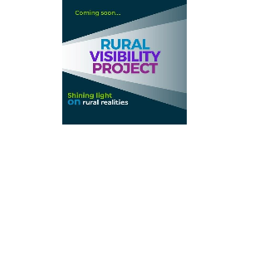
Rural Visibility Project Participation Toolkit
Thank you for joining the Rural Visibility Project.
This guide tells you exactly how to join in, what to post,
when to share, and how to stay connected to the project.
What is the Rural Visibility Project?
A yearlong campaign designed to center rural priorities through
community-driven dialogue between local, state, and regional entities.
This organizing strategy, powered by rural people and structured around monthly topics, aims to shift public attention to the realities, concerns, and possibilities that matter most in the places we call home (see the attached 2-page flyer).
We invite you to be part of this effort to amplify rural voices during each month, focusing on the topics that resonate with you the most. An interest form is available to all who would like to engage on our website (ruralvisibilityproject.org) to inform the RDI team about the months that interest you. Reminder emails for info sessions, community conversations, and the start of each monthly topic will go out to those who fill out the interest form.
Information Sharing Guide
As a participant in this project, you can help amplify rural stories by:
- Sharing 1–2 posts per week that match the weekly theme and align with the monthly issue topic
- Using our shared hashtags and tagging RDI so we can repost
- Lifting up stories, wins, and community voices from your own region.
- Reposting content from monthly Issue Leaders to build momentum
Platforms
Instagram: @rdiinc
Facebook: @RuralDevelopmentInitiatives
LinkedIn: @Rural Development Initiatives
Hashtags
#RuralVisibilityProject (campaign hashtag)
#WeAreRural
#SmallTownBigImpact
#thisisruralwashington, #thisisruralidaho, #thisisruraloregon, #thisisruralamerica)

Not sure what to post? Here are some tips to help you get started!
You do not need brand new content - feel free to re-share posts you have already created in your work, or repost issue specific content you have seen from others in your network.
- Pick a Format
- Photo + caption
- Short video (30–60 sec)
- Quote card or infographic
- Repost from RDI or other partners
- Write a Caption
- Start with a fact or personal story
- Keep it short and clear
- Include a call to action ("Follow us for more," "What do you think?")
- Example:
- Hook: "Did you know that rural Oregon has only 1 mental health provider per 1,000 people?"
- Context: "This is part of why we're investing in peer-led mental health supports in [County]."
- Call to Action: "Follow the #RuralVisibilityProject to learn more."
- Platform tags and Hashtags
Rural Visibility Project – Logos (we can send you separate files – just ask!)
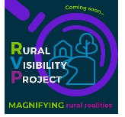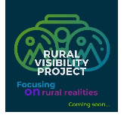

Weekly Posting Schedule
Our campaign will follow the 4-week cadence for each monthly topic:
Week 1: Rural Realities | Share a stat, quote, or story about the monthly topic and how it relates to the way things work in rural communities.
Week 2: Rural Ideals and Successes | Highlight something that works in your work, community, or region: a program, event, strategy, or person that is making a difference.
Week 3: Rural Methods and Models | Highlight models, concepts, and methods that would be successful in a rural community
Week 4: Key Players and Stakeholders | Tag a rural changemaker and share what’s coming up (next steps, events, or policy changes happening soon)

Need Help?
Email kschaffer@rdiinc.org with questions or requests. We are here to support your posts and amplify your voice.
When we all post together, we:
- Show that rural communities are not isolated, they’re connected
- Celebrate what’s working, not just what’s broken
- Influence how policy and decision-makers see and support rural life
You are part of a project to shine light on rural realities. Thank you for raising your voice and helping us make rural visible!
In solidarity,
The RVP Team

